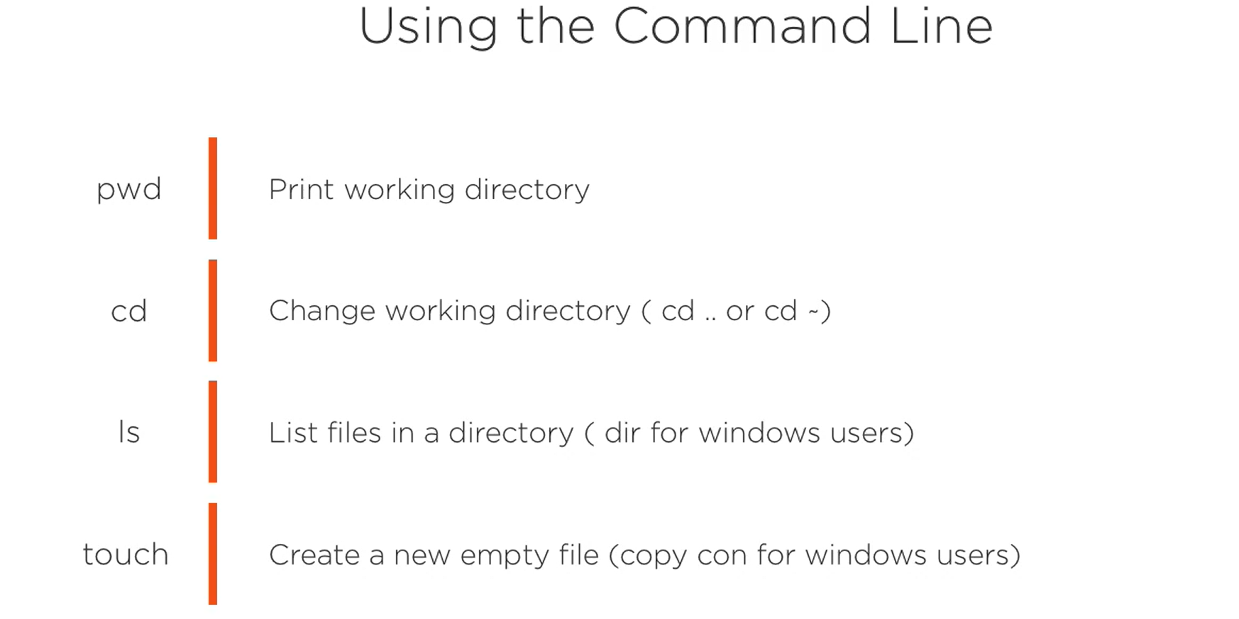



* At command line

1. git –version (for version)

git version 2.35.1.windows.2

1. git config –global user.name “Bindu Kolusu” (Sets the user name as Bindu Kolusu for all the projects if you want to change the configuration for one project you can do git config user.name = “New name”)
2. git config –global user.email [bindu.kolusu@ruralsourcing.com](mailto:bindu.kolusu@ruralsourcing.com)
3. git config –list (to check your configuration settings, it will display all of your configuration settings).
4. git config user.name (If you want to display a specific git setting use config.setting_name in this case I used user.name )
5. man git (kind of help manual in git). High level commands or porcelain commands are the ones that are being used day to day use;
6. git help config (git help nameofthe section you want help with) will display only the manual for config
7. git help – will display set of commands that you will most likely to use everyday.
8. git init (command is used to initialize the repository in the given or current directory. Change the directory to your desired directory inorder to initialize the git repository)

C:\Users\bindu.kolusu\Desktop\Java\Git>git init

Initialized empty Git repository in C:/Users/bindu.kolusu/Desktop/Java/Git/.git/

1. By initializing git repository the git configuration is added to the above directory. By default .git is hidden if you want to go into the directory and see the configuration:

C:\Users\bindu.kolusu\Desktop\Java\Git>cd .git

C:\Users\bindu.kolusu\Desktop\Java\Git\.git>ls

'ls' is not recognized as an internal or external command,

operable program or batch file.

C:\Users\bindu.kolusu\Desktop\Java\Git\.git>dir

Volume in drive C has no label.

Volume Serial Number is DE10-BAEE

Directory of C:\Users\bindu.kolusu\Desktop\Java\Git\.git

02/26/2022 04:58 PM 130 config

02/26/2022 04:58 PM 73 description

02/26/2022 04:58 PM 23 HEAD

02/26/2022 04:58 PM <DIR> hooks

02/26/2022 04:58 PM <DIR> info

02/26/2022 04:58 PM <DIR> objects

02/26/2022 04:58 PM <DIR> refs

3 File(s) 226 bytes

4 Dir(s) 183,980,797,952 bytes free

1. .git directory just contains all of the meta data for the repository.
2. Git repository hosting services (Cloud service for git repository):

1 GitHub

2 GitLab

3. BitBucket

1. echo "#binduk28" >>README.md command says that binduk28 with an h1 html file with new file as README file.